README File
Grazioso Salvare Web Application Dashboard
Najjah Gray-Thompson | CS-340 Project Two
- Overview
  - The purpose of this project was to create a full-stack client/server dashboard application. The dashboard allows users to interact with and visualize animal shelter data stored in MongoDB in order to identify dogs for search and rescue training.
  - The dashboard connects to a MongoDB database using a custom CRUD Python module that I developed in Project One. This interactive web interface allows users to filter data and view information through charts and a geolocation map.
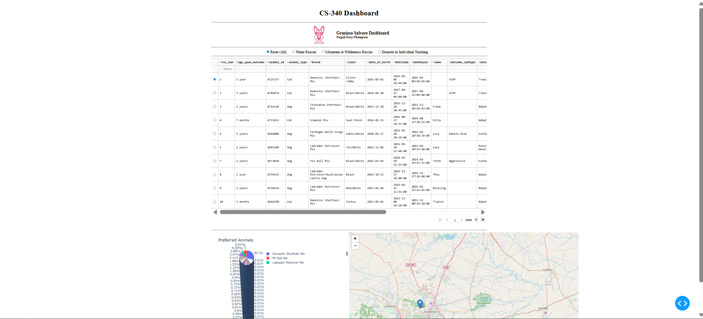
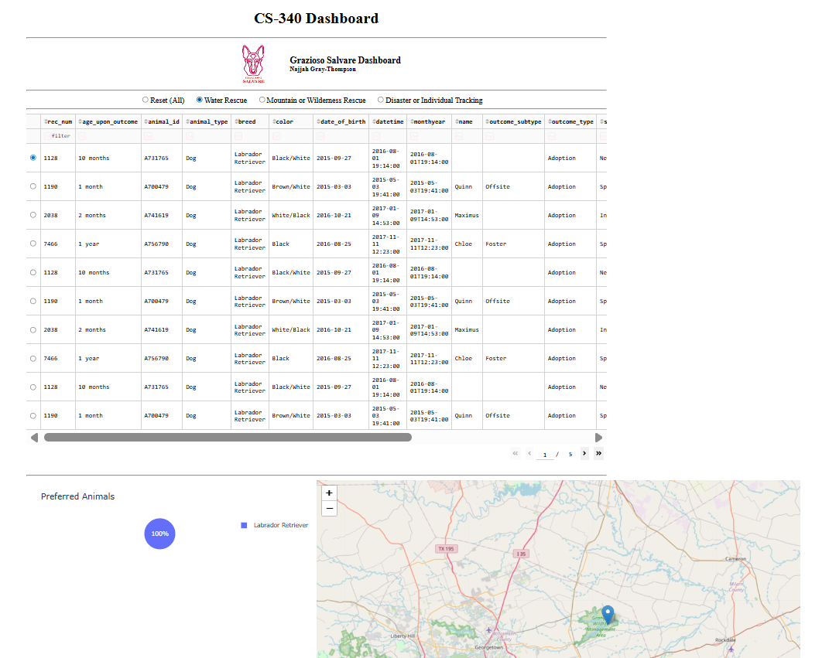
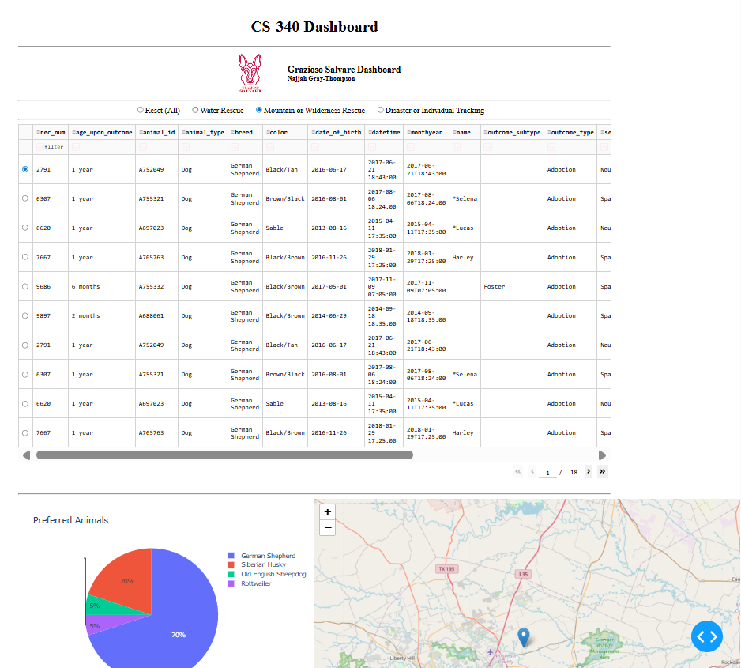
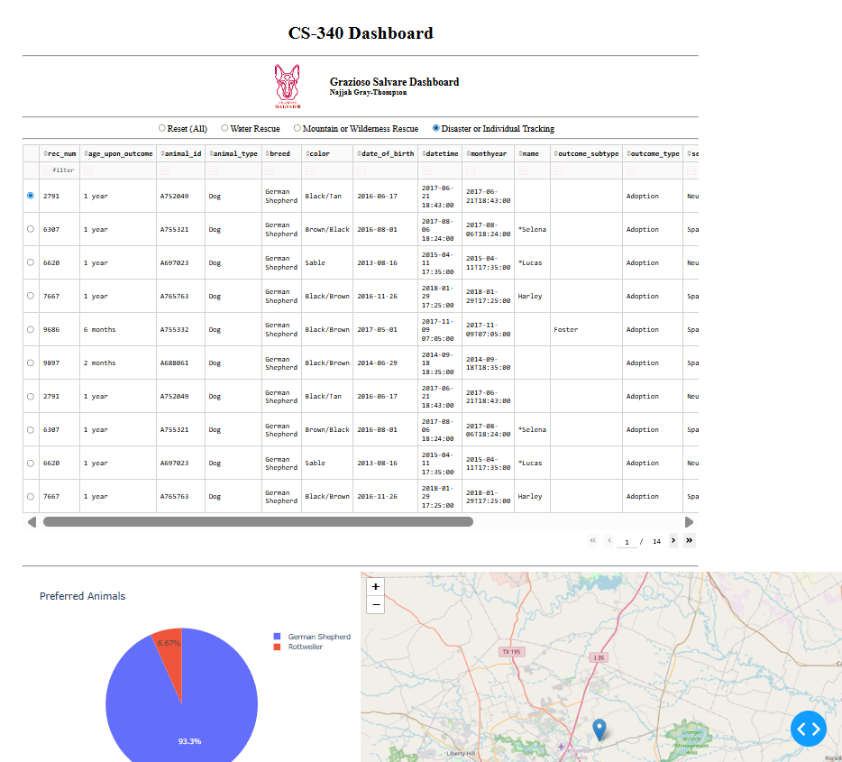
- Required Functionality
  - Required Specifications Include:
    - An unfiltered data table displaying all shelter records
    - Interactive filtering options for:
      - Water Rescue
      - Mountain or Wilderness Rescue
      - Disaster or Individual Tracking
      - Reset (All records)
    - A data table that updates based on the selected filter
    - A geolocation map
    - A data chart
When the user selects a rescue type, the application runs a MongoDB query to filter dogs by breed and age (two years old or younger). The filtered results are returned to the dashboard which updates the data table, pie chart and geolocation map.
- Tools Used
  - MongoDB – used as the database system to store the shelter data. MongoDB is a document-based NoSQL database that works with JSON-style data structures which integrate smoothly with Python.
  - Python – used to implement CRUD functionality, build database queries, and manage the dashboard logic.
  - Dash – used to build the web application interface. It provides the layout components and callback functions that make the dashboard interactive.
  - Plotly Express – used to create the dynamic pie chart.
  - Dash Leaflet – used to generate the geolocation map.
- Steps Taken to Complete Project:
  - Connected the dashboard to MongoDB using the previously developed CRUD module.
  - Retrieved all records to populate the initial unfiltered data table.
  - Removed the _id field to prevent DataTable rendering errors.
  - Created interactive filtering option using Dash RadioItems.
  - Developed MongoDB queries for each rescue type.
  - Connected filters to the table through callback functions.
  - Built a dynamic pie chart using Plotly Express.
  - Implemented a Dash Leaflet map to display geolocation data.
  - Enabled row selection so the map updates based on user choice.
- Challenges
  - The main issue I faced was trying to format my display into suitable user experience. When I initially rendered the images, charts, headers, and graphs, they were not aligned properly. After toggling with the module, I was able to format the webpage successfully.

